Submitted by Submitted To

# Lab Report 01

## Muhammad Awais / 2883 Ma’am Zanaib Malik

Department of Computer Science and Engineering

# National University of modern language, Islamabad

## List of Task

### Concepts of Array

1. Array Declaration

### Array initialization using function

1. Display elements of Array using function

### Find Even Numbers in Array

In this lab we learn three function for **initialization, Display and find Even Number**. Here the description of each function.

## Description of Void initializer

/*write a Function name intilizer that will an arry,

its size as parametrs, this function should initilize the declaraed arry*/ void intilizer(int arr[], int size);// Arry intilizer

### What does Function Do?

1. Void function means **nothing will return.**

### Take an array and size of array as a parameter.

1. Take input from user using loop and store in Array.
2. Use **switch** for menu display which helps to perform task according to **choice of user.**

## Source Code

void intilizer(int arr[], int size)

{

for (int i = 0; i < size; i++)

{

cin>>arr[i]; }

}// End of Initilizer

Output

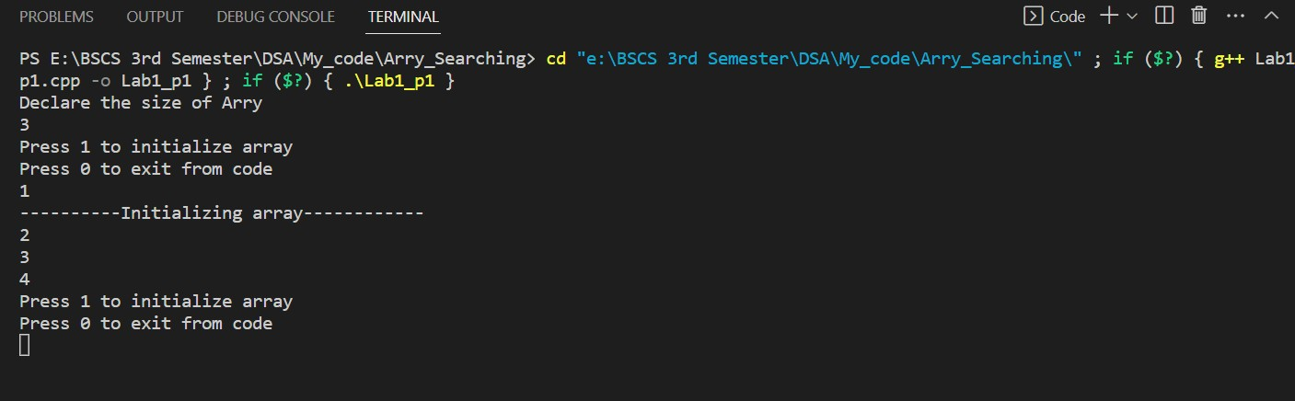

## Description of Void Display

/*write a Function name Display that will an arry,

its size as parametrs, this function should display initilized values of arry*/ void Display(int arr[], int size);// Arry Display

### What does Function Do?

1. Void function means **nothing will return.**

### Take an array and size of array as a parameter.

1. Display element of Array using loop.
2. Use **switch** for menu display which helps to perform task according to **choice of user.**

## Source Code

void Display(int arr[], int size)

{

cout<<"***********Values of Arry********"<<endl;

for (int i = 0; i < size; i++)

{

cout<<arr[i]<<endl;

}

}// End of Display

Output

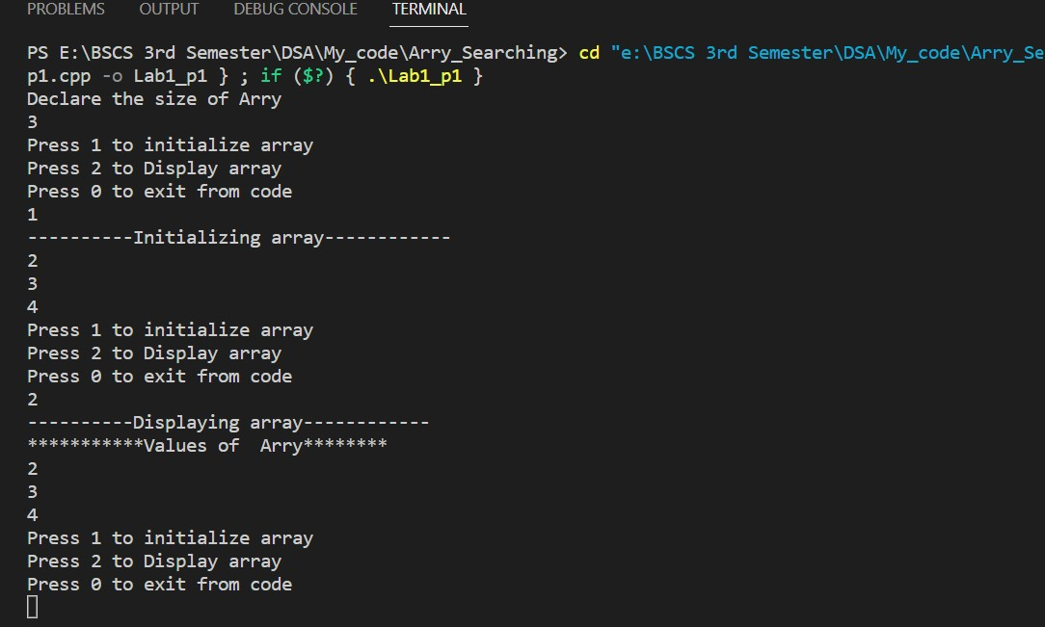

## Description of Void Even Number

/*write a Function name Display that will an arry,

its size as parametrs, this function should display initilized values of arry*/ void Display(int arr[], int size);// Arry Display

### What does Function Do?

1. Void function means **nothing will return.**

### Take an array and size of array as a parameter.

1. Find even number in array.
2. Using **conditional operator if(n%2==0) EvenNo**
3. Use **switch** for menu display which helps to perform task according to **choice of user.**

## Source Code

/*write a Function name evenNo that will an arry,

its size as parametrs, this function should find Even number in the Arry*/ void evenNo(int arr[], int size);// Even Finder

Output

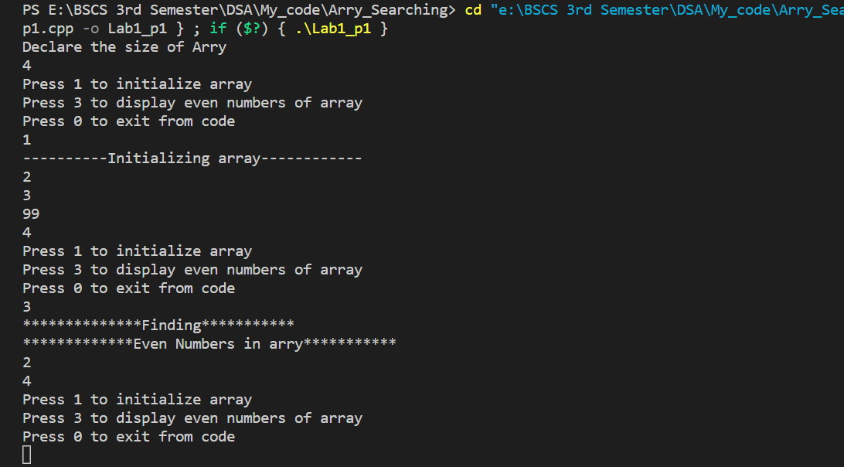

## End of Lab 01